Non-financial statement VIPER 20XX-1

Stakeholder dialogue
Viper plays an important role in The Netherlands as a logistics service provider. We are proud to have grown from start-up to scale up and have involved all our stakeholders throughout the year. The reason why we do this, is because our stakeholders significantly influence the areas that we want to focus on in the short- and long term to create value and grow further. Each stakeholder group has indicated what topics are important and relevant to them. Based on all the inputs from these groups, we identify the topics that are most material and should be prioritized. We intend to perform this process every year and publicize an update on our progress in this annual report.

Stakeholders
We engage with our stakeholders in different ways, on different moments within the year and focused on different topics, to understand their needs and interests. Our main stakeholder groups are summarized below.

Customers
Our customers are our key stakeholder group and are the reason we exist. We identify two types of customers who order products from us. The first are business customers, ranging from one-person companies to multinational organizations, and the second are consumers. We engage with each on different topics, as the impact we make on both sub-groups is different. Our business partners expect seamless, high quality, sustainable services delivered quickly and conform the agreements made. Consumers expect Viper to be easily accessible, to offer a wide variety of products that are energy efficient, and they require more flexible delivery options and timeslots.

Our employees
Viper has grown from a start-up to a business in the last few years and our employees are the key drivers behind this growth. Without them, we would be nowhere and they are key to delivering our services. The main topics we discuss with our employees relate to the working conditions and discussing innovative ideas to further improve our (business) processes. We collaborate closely with trade unions to make sure our employees are working in a healthy and safe environment, whether in our warehouse, on the road or anywhere else as part of working for Viper.

Investors
A good financial position and performance throughout the years is important for our investors and shareholders, as well as banks.
The main topics that we discuss with this stakeholder group are the business drivers, business risks, financial performance, creating value and our short and long-term business outlook.

Government bodies
It is essential for Viper to engage with local and national governments, regulators and the general political arena about policy and regulatory developments. This includes topics such as the future of the Dutch delivery market, labour relations and future city logistics, including environmental criteria such as the ‘milieu-zone’ that has been implemented in several cities already.

Opinion leaders and society at large
Viper also actively asks for inputs from NGOs and academic and research institutions. Because they see Viper from very different perspectives, this helps us to identify key areas for improvement, but also identify new or unidentified areas from other stakeholders as well. An example of such an area is the environmental impact that Viper has in The Netherlands. With these various stakeholders we engage mainly during business events on topics such as market trends, environmental and social issues and delivery times in larger cities.
Business partners
Suppliers and other business partners are an essential stakeholder group to Viper, as they help us execute our work on a just-in-time basis and are therefore key partners in realizing high quality product delivery. This includes suppliers of IT services, goods, trucks and other organizations from which we purchase services. Topics we regularly discuss with business partners are ethics, responsible procurement practices and (data) privacy.

Material topics
Based on all topics discussed with our stakeholder groups, we have gathered input and quantified the relevance and importance of these topics into a materiality matrix. For the annual report, we focus on our most material items for further disclosure. The prioritization of topics is made based on a materiality analysis process, and then ranked based on two dimensions:
- The topic’s influence on stakeholder assessments and decisions (the vertical axis of the matrix).
- The significance and impact of Viper with the topic on its operating environment (the horizontal axis of the matrix).
The topics in the upper right-hand corner of the matrix represent the key material topics that are further elaborated on in this annual report. This does not mean that the other topics are not important to Viper, as all topics identified in our matrix are also included in, amongst others, our strategy and labour CAO.
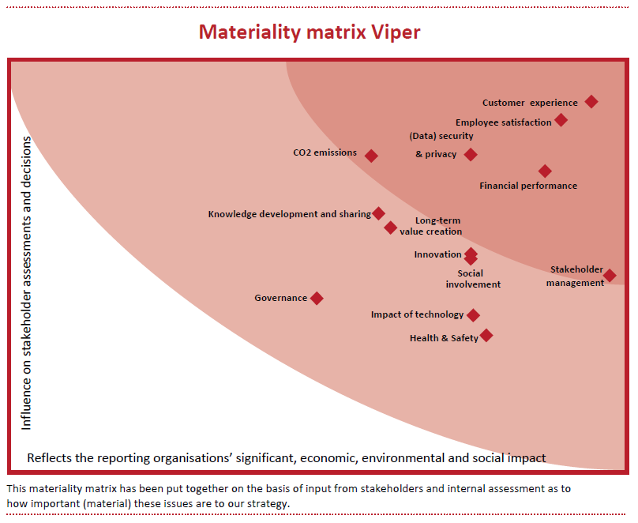

- Customer experience
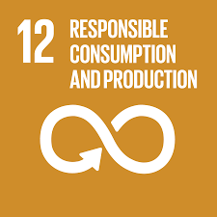
Customer experience is key to our business. We want to keep and make our customers happy and make sure they come back to us for more services and products. That is our driving force and what we ultimately want to achieve.
For each product type, we make sure that the product is delivered to the client quickly. Also, we take into account the energy consumption of the specific product and make sure that we have sufficient energy-saving alternatives. For some products, our customers do not just want a good, rapid delivery of products, but actually really need it; e.g. in the case of a new washing machine, they much prefer a next-day delivery service. To make sure we can deliver on our promises, we make sure important elements are up to par: a quick delivery service, an installation service, a customer service, and a repair service. This makes us a customer-focussed company. To monitor whether we are on the right track, we always ask for feedback from our clients via a survey, after an order is delivered. We have received over 20.000 feedback scores in the last year and are proud to report that the customer satisfaction score has improved further in comparison to prior year. Our target of an 8.0 average has not yet been reached, however we feel we are on the right path to reaching this goal within the next two years.
KPI | 20XX-2 | 20XX-1 | Target score
Customer satisfaction score | 7,7 | 7,8 | 8,0
Churn rate within the FY | 4,3% | 4,0% | Not more than 5%

- Employee satisfaction

Viper is a ‘people company’. Without our employees, we are not able to operate, so they are a crucial element of the business. We need productive, skilled, motivated and service-oriented people to execute our strategy and contribute to the delivery of our services. By operating and developing an inclusive organization, we aim to help our human capital to grow whilst also providing a safe and healthy work environment.
We have a clear strategy and training programs in place to help our employees develop and feel empowered within the company. In peak periods, we can scale up our own employees, attract temporary workers and scale up through our delivery partners when needed. We aim to provide favourable work conditions for our entire workforce. In a high volume, rapidly growing logistics business, effective staffing and planning are key success factors. Work and personnel planning, targeted recruitment, employee on boarding through training, and retention is based on the employee feedback that we receive. This ensures we can deliver what we promise to our customers.
The majority of our people have task-oriented jobs, with our drivers and deliverers required to carry out their duties primarily on their own. At the same time, they are the face of Viper and are the ones in direct contact with our customers. Viper therefore considers listening to our own employees and engaging them in decision processes to be very important.
As Viper strives to build a workforce, which represents society, we aim at creating a very diverse employee base in our workforce. Diversity and inclusion is important to Viper as through incorporating different types of people, with different backgrounds, preferences and perspectives, we can further grow our business.
We have had a collective labour agreement (CAO) in place for many years now, in which Labour conditions have been agreed upon. This CAO is regularly reviewed and updated. The next update will be next year and Viper is looking forward to starting this conversation again with the trade union.
KPI | 20XX-2 | 20XX-1 | Target score
Employee engagement score | 7,0 | 6,5 | 8,0
Ratio of basic salary and remuneration of women to men | 0.9 | 0.91 | 1
Female vs male FTE | 30% | 28% | 50%

- Data security & privacy

Our organization is GDPR proof. The European General Data Protection Regulation (‘AVG’ in Dutch) came into effect as of 25 May 2018. GDPR has considerable impact on the way we deal with and process data and it affects the way of working in all departments of our firm. We have put significant effort into identifying all our services and applications to enable us to register all the personal information we process. And in order to be compliant with the GDPR, we have updated our policies for processing, registering and retaining personal data.
In the context of GDPR we have also appointed a data privacy officer, responsible for informing and advising the board and our people on the requirements of GDPR and for monitoring compliance with the new regulation. The data privacy officer will take initiatives to raise awareness and training and is the primary point of contact together with our Data Protection Officer for all things GDPR.

KPI | 20XX-2 | 20XX-1 | Target score
Number of data breaches reported to APG | 0 | 1 | 0
Substantiated complaints concerning breaches of customer privacy and losses of customer data | 0 | 0 | 0

- Financial performance
Please refer to our financial statements for insight into our financial performance and further disclosures made with regard to this topic. Our Key KPIs to measure financial performance are:
- Revenue growth
- Operating margin
- Burn rate

- CO2 emissions

It is our ambition to reduce carbon emissions by 50% by 2030. To reach this goal, we reduce the CO2 emissions in all our processes as much as possible and want to compensate for the CO2 emissions we cannot avoid through e.g. CO2 certificates. Together with other transport companies in the sector, we want to join efforts to reach a general reduction in CO2 emissions as a whole. Our distribution centres are set up as efficiently as possible and as part of our continuous improvement plan, we seek further efficiencies where possible. We are close to highways and other transport routes so we can quickly send our trucks out for delivery without having a lot of (negative) impact in residential areas with regard to CO2 emissions as well as noise.
Our products are stored, packed and delivered in recyclable and sustainable crates, boxes or other wrapping that is necessary for that specific product. We take the packing material back to our warehouses after the products are delivered so we can recycle the material and make efficient use of our materials. We take back products that customers have replaced (e.g. washing machine) and make sure this is recycled in a sustainable manner at our warehouse/ distribution centre.
In all our office, distribution centre and warehouse areas, we are aware of our water, electricity, heating and cooling consumptions and have made efforts to make sure that we are working towards a 25% reduction of our energy consumption in these areas by 2030. An example of this is the installation of ‘smart climate installations’ that automatically cool or heat a room, depending on the time of day, people present and temperature outside. In addition, Viper is working on obtaining an ISO 14001 certificate in the coming year.
KPI | 20XX-2 | 20XX-1 | Target
CO₂ emissions (tonne) | 300 | 289 | A reduction in Viper’s carbon emissions by 50% by 2030, relative to 20XX-2 levels.
Product recycling rate (%) | 44,3% | 66,5% | 80%
Energy consumption/m2 (kWh/m2) | 210 | 220 | An increase in Viper’s energy efficiency p/m2 of 30% by 2030, relative to 20XX-2 levels.
Water consumption (m3) | 207.360 | 205.856 | A reduction in water consumption by 25% on Viper’s offices and warehouses by 2030, relative to 20XX-2 levels.
% of sustainable purchases | 60% | 72% | At least 75% of purchases, should be obtained from certified and/or sustainable suppliers

- Stakeholder management
Through our annual reports, information on our website and the regular newsletters we send out to all our share- and stakeholders, we continuously involve the different parties. Through this continuous communication back and forth, we update our understanding of stakeholder needs regularly. This enables us to make changes quickly where necessary in elements of our business, e.g.; our strategy, our way of delivery, and the manner of transportation of our products.

the % of customers who cut ties with the company during the fiscal year
This rate is used to determine how quickly the company is burning cash within a fiscal year.
Suppliers are considered to be sustainable if any of the following certifications are obtained by the suppliers and sent to Viper: Global Food Safety Initiative (GFSI), UTZ, Rainforest Alliance, Fairtrade, TÜV, ISO 14001 & OHSAS 18001 certified suppliers. If not certified, suppliers/products are considered to be sustainable if: the product has at least an energy label B.

